DNS MX Record

📧 What is a DNS MX Record?
# Source: Chatgpt (GPT-5-Mini) at [1/18/2026]
An MX Record (Mail Exchange Record) specifies the mail server(s) responsible for receiving email on behalf of a domain.
🧠 It tells the internet:
"Send email for this domain to these mail servers."

🔍 Details of MX Record
# Source: Chatgpt (GPT-5-Mini) at [1/18/2026]
- Purpose: Directs email to the correct mail servers.
- Format:
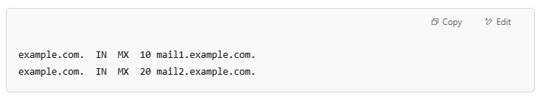
example.com. IN MX 10 mail1.example.com.
example.com. IN MX 20 mail2.example.com.
- Priority: The number (e.g., 10, 20) indicates priority — lower numbers have higher priority.

🌐 How MX Records Work
# Source: Chatgpt (GPT-5-Mini) at [1/18/2026]
When someone sends an email to user@example.com:
- The sender’s mail server queries DNS for the MX records of example.com.
- It gets a list of mail servers and their priorities.
- It tries to deliver mail to the mail server with the lowest priority number first.
- If that server is unavailable, it tries the next one, and so on.

🔁 Relation with Other Records
# Source: Chatgpt (GPT-5-Mini) at [1/18/2026]
- MX records point to domain names, not IP addresses.
- The target mail server domain must have an A or AAAA record so it can be resolved to an IP.

Example
# Source: Chatgpt (GPT-5-Mini) at [1/18/2026]
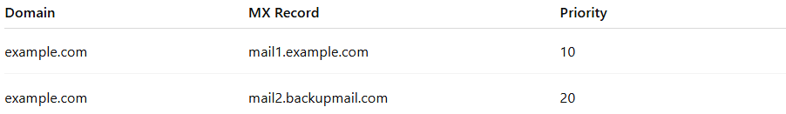
Domain | MX Record | Priority
example.com | mail1.example.com | 10
example.com | mail2.backupmail.com | 20

✅ Summary
# Source: Chatgpt (GPT-5-Mini) at [1/18/2026]
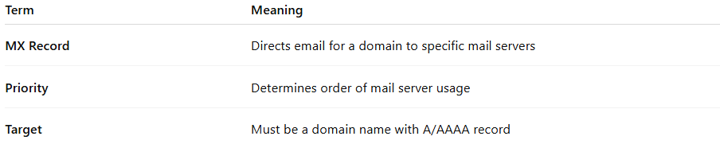
Term | Meaning
MX Record | Directs email for a domain to specific mail servers
Priority | Determines order of mail server usage
Target | Must be a domain name with A/AAAA record

